

**NAME:-SYED.MANSOOR BASHA**

**REG.NO:-192111385**

**COURSE.CODE:-CSA1190**

**COURSE.NAME:-OBJECT ORIENTED ANALYSIS AND DESIGN**

**EXPERIMENT-21:-**

**AIM:-** To draw the UML diagrams for hospital management system using umbrello.

**DESIGNS:-**

**CLASS DIAGRAM:-**

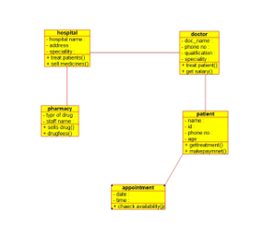

**PACKAGE DIAGRAM:-**

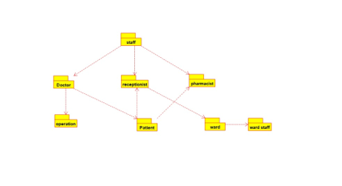

**DEPLOYMENT DIAGRAM:-**

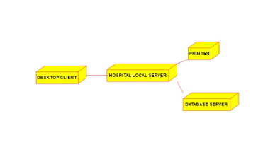

**RESULT:-** The uml diagrams of program was executed successfully by using umbrello.

**EXPERIMENT-22:-**

**AIM:- :** To draw UML diagram for online insurance system using umbrello.

**DESIGNS:-**

**ACTIVITY DIAGRAM:-**

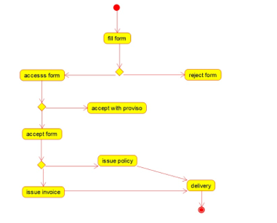

**SEQUENCE DIAGRAM:-**

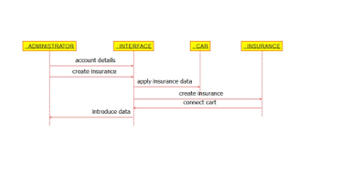

**USE-CASE DIAGRAM:-**

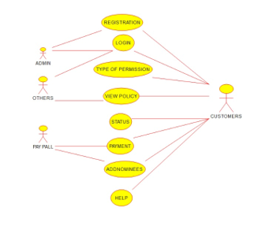

**RESULT:-** The uml diagrams of program was executed successfully by using umbrello.

**EXPERIMENT-23:-**

**AIM:-** : To draw the uml diagram for online shopping system using umbrello.

**COMPONENT DIAGRAM:-**

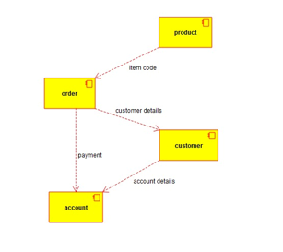

**USE-CASE DIAGRAM:-**

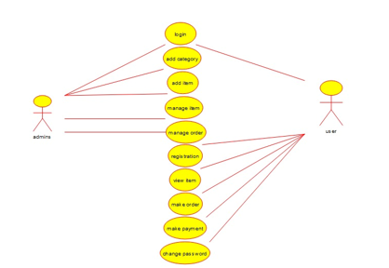

**ACTIVITY DIAGRAM:-**

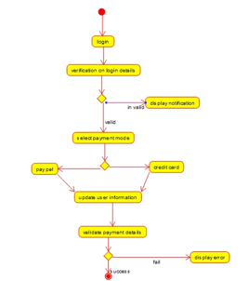

**RESULT:-** The uml diagrams of program was executed successfully by using umbrello.

**EXPERIMENT-24:-**

**AIM:-** To draw the uml diagram for online stock market using umbrello.

**DESIGNS:-**

**SEQUENCE DIAGRAM:-**

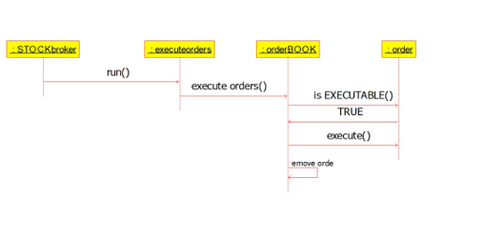

**DEPLOYMENT DIAGRAM:-**

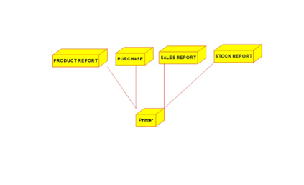

**COMPONENT DIAGRAM:-**

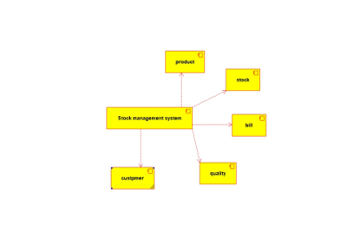

**RESULT:-** The uml diagrams of program was executed successfully by using umbrello

**EXPERIMENT-25:-**

**AIM:-** To draw the uml diagram for online voting system using umbrello.

**DESIGNS:-**

**ACTIVITY DIAGRAM:-**

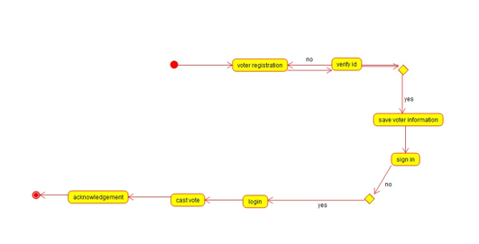

**COMPONENT DIAGRAM:-**

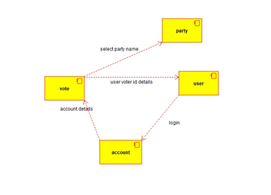

**CLASS DIAGRAM:-**

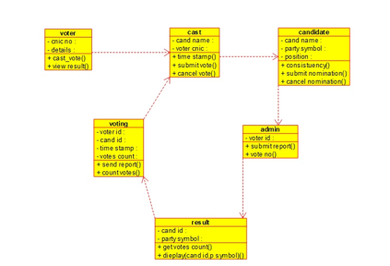

**RESULT:-** The uml diagrams of program was executed successfully by using umbrello.

**EXPERIMENT-26:-**

**AIM:-** To draw the UML diagrams for jewellery shop management system using umbrello.

**DESIGNS:-**

**USE-CASE DIAGRAM:-**

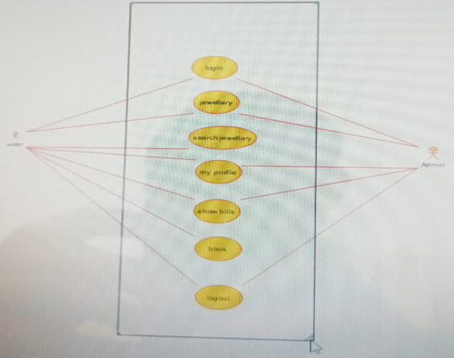

**SEQUENCE DIAGRAM:-**

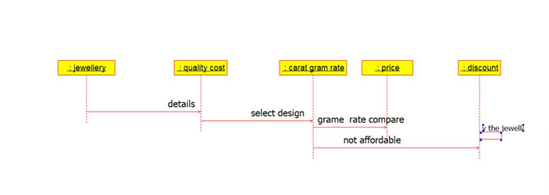

**COMPONENT DIAGRAM:-**

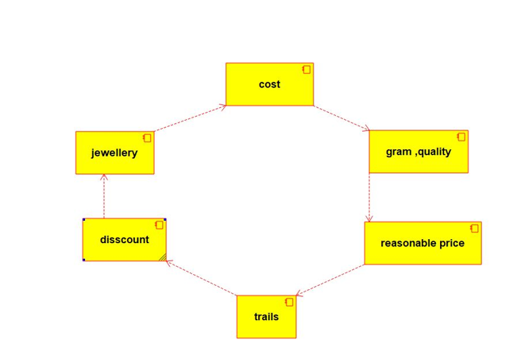

**RESULT:-** The uml diagrams of program was executed successfully by using umbrello.

**EXPERIMENT-27:-**

**AIM:-** To draw the UML diagrams for SUPER MARKET MANAGEMENT SYSTEM.

**DESIGNS:-**

**USE-CASE DIAGRAM:-**

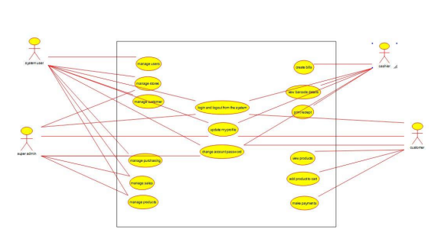

**ACTIVITY DIAGRAM:-**

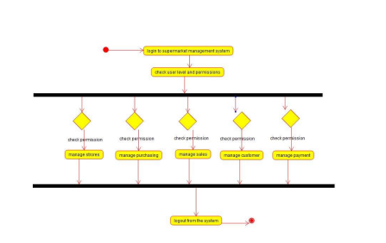

**CLASS DIAGRAM:-**

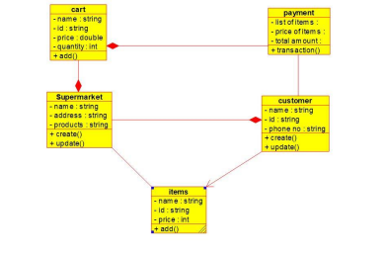

**RESULT:-** The uml diagrams of program was executed successfully by using umbrello.

**EXPERIMENT-28:-**

**AIM:-** -To draw the UML diagrams for AIRLINE RESERVATION SYSTEM.

**DESIGNS:-**

**CLASS DIAGRAM:-**

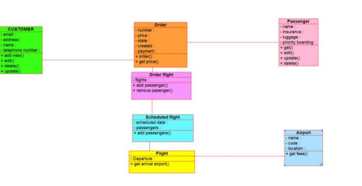

**ACTIVITY DIAGRAM:-**

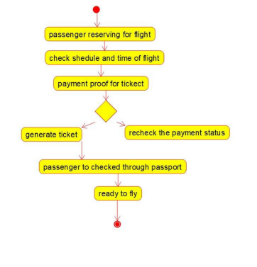

**USE-CASE DIAGRAM:-**

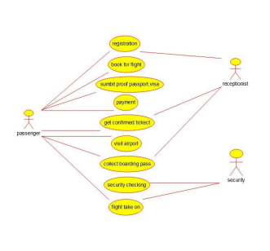

**RESULT:-** The uml diagrams of program was executed successfully by using umbrello.

**EXPERIMENT-29:-**

**AIM:-** To draw the UML diagrams for BUS TICKET RESERVATION SYSTEM.

**DESIGNS:-**

**CLASS DIAGRAM:-**

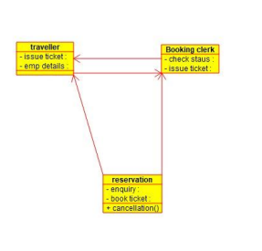

**COMPONENT DIAGRAM:-**

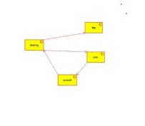

**USE-CASE DIAGRAM:-**

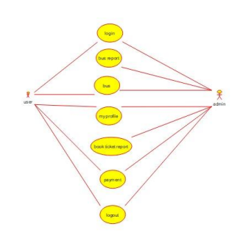

**RESULT:-** The uml diagrams of program was executed successfully by using umbrello.

**EXPERIMENT-30:-**

**AIM:-** To draw the UML diagrams for TRAIN RESERVATION SYSTEM.

**DESIGNS:-**

**USE-CASE DIAGRAM:-**

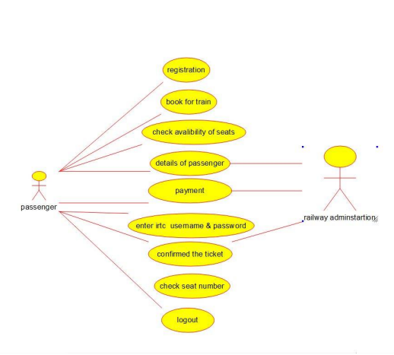

**ACTIVITY DIAGRAM:-**

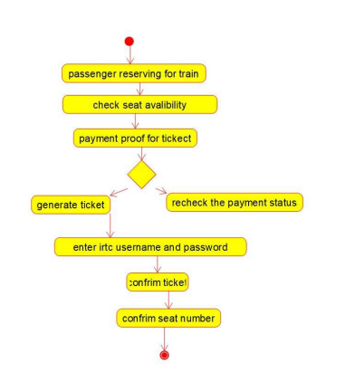

**COMPONENT DIAGRAM:-**

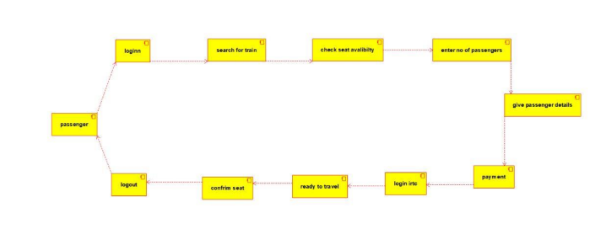

**RESULT:-** The uml diagrams of program was executed successfully by using umbrello.